1.WWP to find the area of a circle by using required window controls.

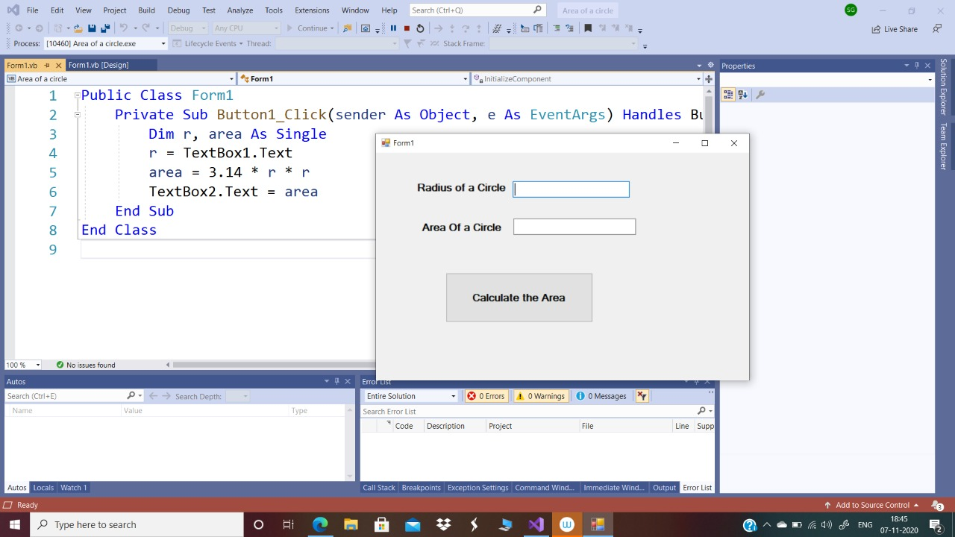

2. WWP to calculate sum of the digits of number entered by user

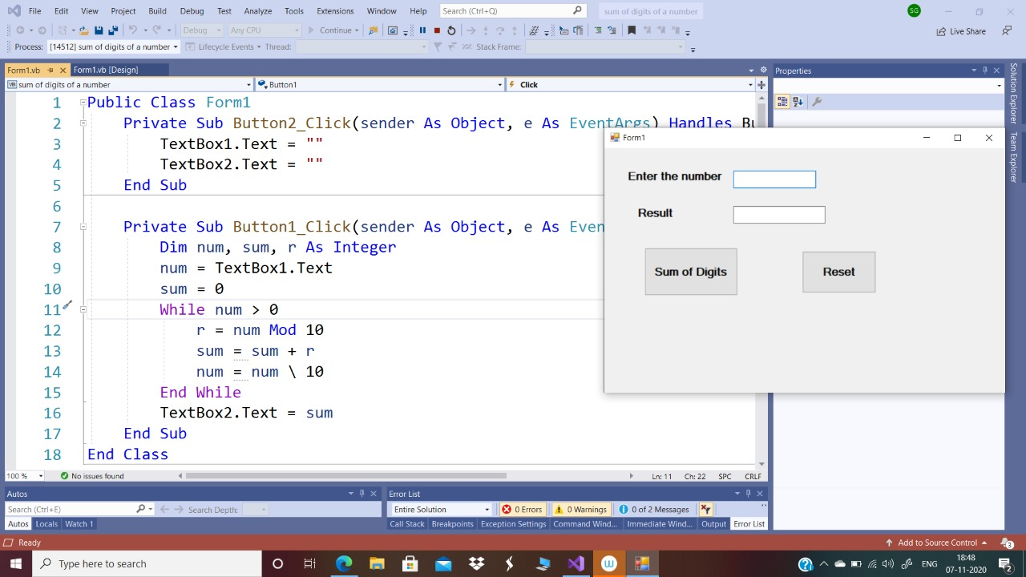

3. WWP to find reverse of a number

